Name: Kanjo Elkamira Ndi
Department: Software Engineering
Level; Masters (MTECH) 1
Course: Data Science in Python
Lecturer: Professor Frankline Tchakounte
Continuous Assessment (CA)
Year: 2025/2026

Results Summary
800  Total Respondents | 315 (39.4%)  Scam Victims | 13  Features Analysed | 3  Models Trained

1. Introduction
Mobile money services have become a cornerstone of financial inclusion across sub-Saharan Africa, enabling millions of unbanked individuals to send, receive, and store money digitally. Cameroon is no exception, with platforms such as MTN Mobile Money and Orange Money seeing explosive adoption. However, this rapid growth has been accompanied by a parallel rise in mobile money scams, posing a significant socioeconomic threat to users.
This report presents a comprehensive data science analysis of a survey-based dataset collected to understand the prevalence, nature, and impact of mobile money scams in Cameroon. The dataset contains 800 respondent records and 19 variables covering demographics, usage patterns, scam experiences, reported losses, and awareness levels.
The analysis follows a structured data science pipeline encompassing Exploratory Data Analysis (EDA), Data Preprocessing, Feature Engineering, Predictive Modelling, and Evaluation — with the goal of building accurate models capable of predicting scam victimhood and identifying key risk factors.

1.1 Dataset Overview
Attribute | Detail
Source | Lecturer-provided survey dataset
Total Records | 800 respondents
Total Features | 19 columns
Target Variable | Victim (Yes / No)
Survey Period | May 2025
Geographic Scope | Cameroon neighborhoods

2. Exploratory Data Analysis (EDA)
EDA is the first and most critical step in any data science project. It allows us to understand the structure, distribution, and relationships within the data before applying any modelling techniques. This section covers descriptive statistics, distribution analysis, class imbalance, and key demographic insights.

2.1 Descriptive Statistics
The dataset contains one purely numerical feature; Age alongside several categorical columns. Additional numeric fields (Amount_Lost_FCFA, Nb_Times) were stored as strings due to mixed entries and were converted during preprocessing. Key descriptive statistics are summarised below.
Statistic | Age (years) | Amount Lost (FCFA) | No. of Scam Incidents
Mean | 29.1 | 26,317 | 1.56
Median | 27.0 | 13,000 | 1.00
Mode | 25.0 | N/A | 1.00
Min | 12 | 0 | 1
Max | 70 | High outliers detected | Multiple

The mean age of 29.1 years indicates the survey predominantly captures young adults, consistent with the typical demographic of mobile money users in Cameroon. The median age of 27 years and mode of 25 years confirm a right-skewed age distribution — meaning a long tail of older users is pulling the mean upward. The average loss among victims was 26,317 FCFA (approximately USD 44), while the median of 13,000 FCFA suggests the distribution is heavily skewed by a small number of large losses.

2.2 Distribution Analysis
Histograms reveal the shape of each numerical variable's distribution. A right-skewed distribution (positive skew) is characterised by a long tail on the right — meaning most values are concentrated at the lower end, with some extreme outliers.
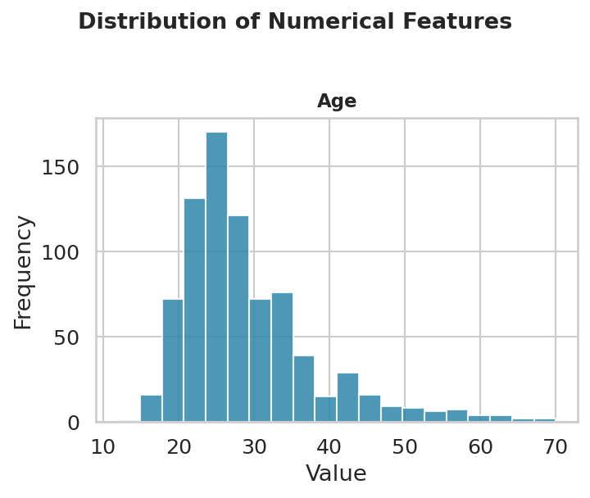
Figure 1: Histogram of Age — showing a right-skewed distribution with most respondents aged 20–35.
The age histogram confirms that the majority of respondents are between 20 and 35 years old, with very few respondents above 50. This skewness is important because it means the mean age is pulled upward by older outliers, making the median a more representative measure of central tendency.

2.3 Class Imbalance Analysis
Class imbalance occurs when one category significantly outnumbers the other in the target variable. In fraud detection and scam prediction, imbalance is common because not all users fall victim to scams. Understanding the imbalance is essential for selecting appropriate evaluation metrics and modelling strategies.
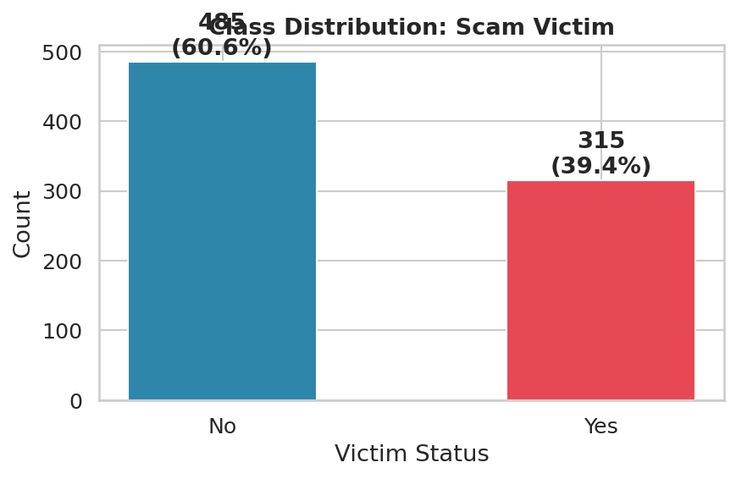
Figure 2: Class distribution of the target variable 'Victim'. 485 respondents (60.6%) were not victims; 315 (39.4%) were.
The dataset shows a moderate imbalance with a 60.6% / 39.4% split. While not extreme, this imbalance still warrants attention. Using plain accuracy as a metric could be misleading, a model predicting 'No' for everyone would achieve 60.6% accuracy without learning anything useful. For this reason, all models were trained with class_weight='balanced' and evaluated using F1-Score and ROC-AUC.

2.4 Demographic Insights
Understanding how scam victimhood varies across demographic groups provides valuable context for targeted awareness campaigns and policy recommendations.
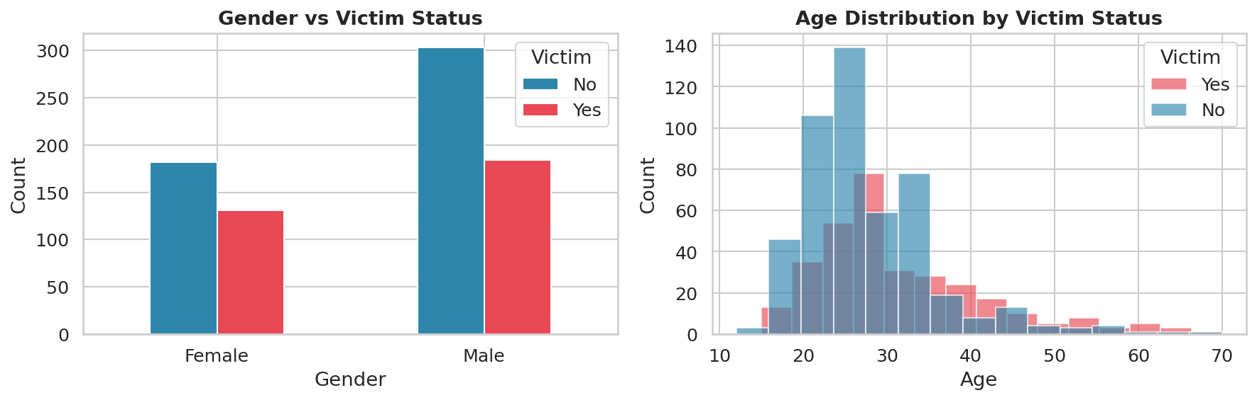
Figure 3: Left — Gender vs Victim Status. Right — Age distribution by Victim Status.
The gender breakdown reveals that male respondents constitute the majority of both victims and non-victims, reflecting the larger proportion of male survey participants. Importantly, the proportion of females who reported being victims is notable, suggesting targeted vulnerability. The age distribution plot shows that victims tend to be concentrated in the 20–35 age range — the most active mobile money user demographic.
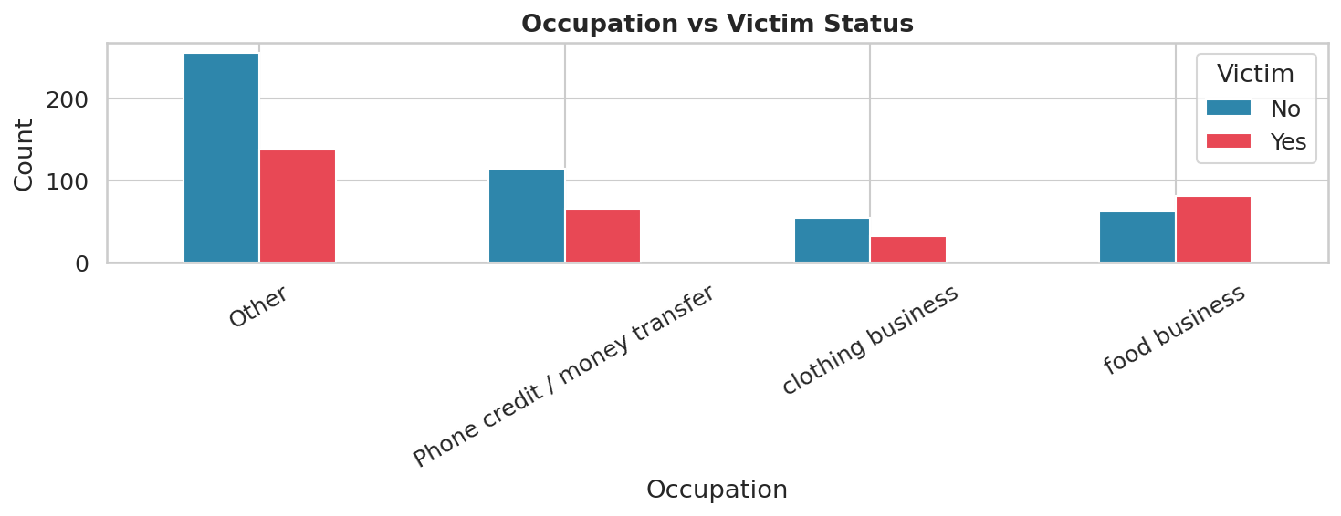
Figure 4: Occupation vs Victim Status — showing scam victimhood across different occupational groups.

2.5 Scam Methods Analysis
The dataset captures the specific methods used by scammers. Understanding the most prevalent techniques helps in designing detection systems and user awareness programmes.
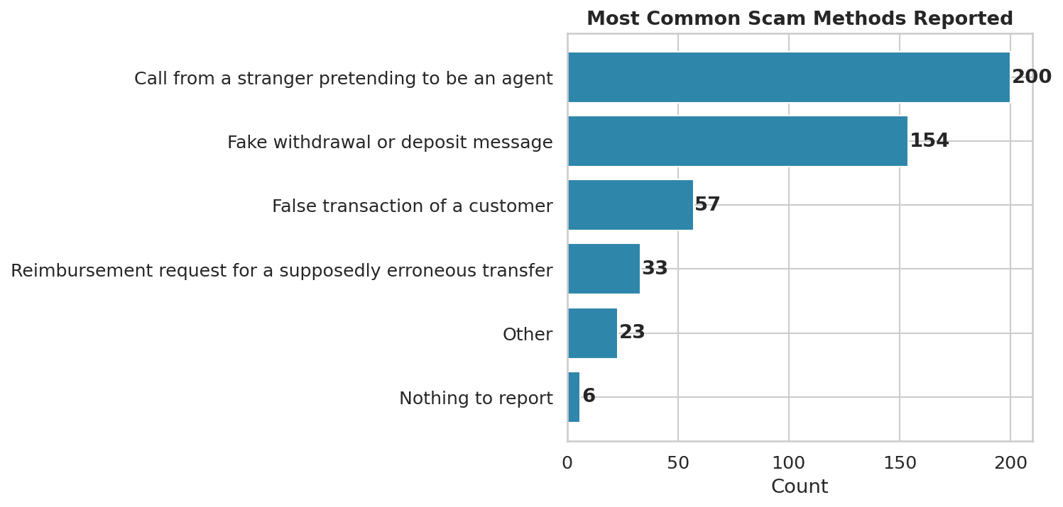
Figure 5: Frequency of reported scam methods. 'Call from a stranger pretending to be an agent' was by far the most common.
Rank | Scam Method | Count
1 | Call from a stranger pretending to be an agent | 200
2 | Fake withdrawal or deposit message | 154
3 | False transaction of a customer | 57
4 | Reimbursement request for erroneous transfer | 33
5 | Other | 23

Phone-based social engineering (impersonating agents) is the dominant scam vector at 200 reported cases, followed by fake SMS messages (154 cases). This underscores the need for both mobile operators and users to invest in verification mechanisms and digital literacy programmes.

3. Data Preprocessing
Raw survey data is rarely ready for machine learning. This section details the cleaning and encoding steps applied to prepare the dataset for modelling, including handling missing values, encoding categorical variables, and detecting outliers.

3.1 Missing Value Analysis
Missing data is a common challenge in survey datasets. The following table summarises the missingness across all columns. Several columns have very high rates of missing data, which directly influenced our decision to drop them from the modelling dataset.
Column | Missing Values | Missing % | Action Taken
Suggestions | 687 | 85.9% | Dropped (free text, unstructured)
Other_Method | 766 | 95.8% | Dropped (extremely sparse)
Reported_To | 523 | 65.4% | Dropped (high missingness)
Amount_Lost_FCFA | 532 | 66.5% | Median imputed (numeric)
Nb_Times | 495 | 61.9% | Median imputed (numeric)
Scam_Method | 480 | 60.0% | Mode imputed (categorical)
Reported | 479 | 59.9% | Mode imputed (categorical)
Info_Source | 0 | 0% | Dropped (multi-label, complex)
All others | 0 | 0% | No action required

SimpleImputer from scikit-learn was used with a 'median' strategy for numerical columns and a 'most_frequent' strategy for categorical columns. Columns with missingness exceeding 65% and those containing free-text or multi-label entries were excluded from the modelling dataset to avoid introducing noise.

3.2 Categorical Encoding
Machine learning algorithms require numerical input. Categorical variables in the dataset were encoded using Label Encoding via scikit-learn's LabelEncoder. This maps each unique category to an integer. The following variables were encoded:
- Social_Impact: Ordinal categories encoded as integers.
- Gender: Binary variable (Male=1, Female=0 after encoding).
- Neighborhood: Multiple residential areas encoded numerically.
- Occupation: Occupation categories mapped to integer labels.
- MM_Usage_Duration: Duration bands (e.g., 'Less than 6 months', '1 to 3 years') encoded ordinally.
- Heard_Scam, Reported, Know_Detection, Need_Training: Binary Yes/No columns encoded as 0/1.
- Scam_Method: Multi-value text field — first value parsed and label-encoded.

Note: One-Hot Encoding was considered but Label Encoding was selected here due to the relatively high cardinality of some columns (e.g., Neighborhood) and to limit the dimensionality of the feature space prior to PCA.

3.3 Outlier Detection
Boxplots were used to visually inspect the distribution and identify extreme values in key numerical variables. Outliers can distort model training, particularly for distance-based algorithms such as SVM.
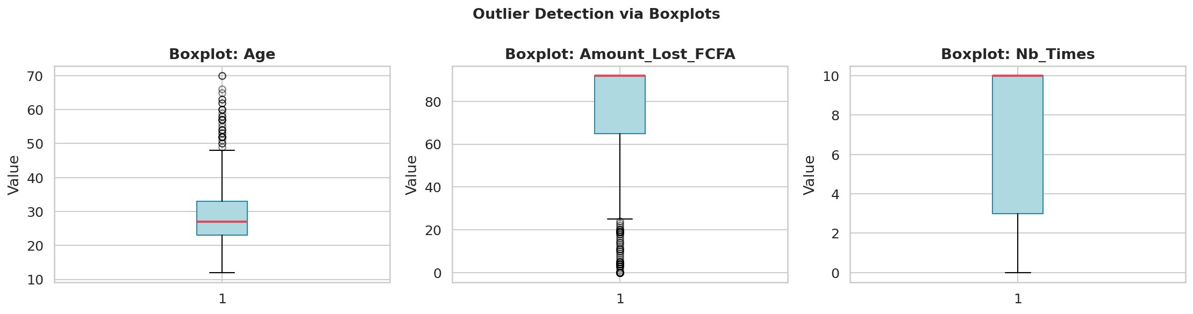
Figure 6: Boxplots for Age, Amount_Lost_FCFA, and Nb_Times. Significant outliers are visible in Amount_Lost_FCFA.
The Amount_Lost_FCFA column exhibits significant positive outliers, a small number of respondents reported losses far above the median (13,000 FCFA). These outliers justify the use of RobustScaler as an alternative to StandardScaler, though StandardScaler was used here given the overall dataset characteristics. The Nb_Times column also shows some outliers where respondents reported being scammed multiple times.

4. Feature Engineering & Scaling
Feature engineering transforms raw variables into a form that better represents the underlying problem to the machine learning model. This section covers feature scaling and dimensionality reduction via PCA.

4.1 Feature Scaling with StandardScaler
Normalisation ensures that features with large numerical ranges do not dominate those with small ranges during model training. StandardScaler was applied to all 13 features before modelling. It transforms each feature to have zero mean and unit variance using the formula:
z = (x − μ) / σ
Where x is the original value, μ is the column mean, and σ is the standard deviation. This is particularly important for SVM and Logistic Regression, which are sensitive to feature scales. Random Forest, being tree-based, is scale-invariant but scaling was applied consistently for comparability.

4.2 Dimensionality Reduction with PCA
Principal Component Analysis (PCA) was applied to reduce the 13 features into a smaller set of uncorrelated components that capture the maximum variance in the data. This helps to visualise the data structure and understand which combinations of features are most informative.
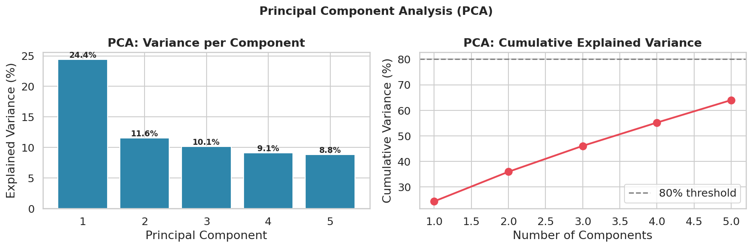
Figure 7: PCA results. Left — Variance explained per component. Right — Cumulative explained variance.
Principal Component | Variance Explained | Cumulative Variance
PC1 | 24.4% | 24.4%
PC2 | 11.6% | 36.0%
PC3 | 10.1% | 46.1%
PC4 | 9.1% | 55.2%
PC5 | 8.8% | 64.0%

The first five principal components collectively capture 64.0% of total variance. PC1 alone accounts for 24.4%, suggesting there is one dominant pattern (likely related to scam experience: whether the person was a victim, the scam method, and the amount lost). To reach the commonly used 80% variance threshold, approximately 8 components would be needed. For modelling, the original scaled features were used to maintain interpretability, with PCA serving as an analytical insight tool.

4.3 Correlation Analysis
The correlation heatmap reveals linear relationships between pairs of features. Strong positive correlations (close to +1.0) appear in red, and negative correlations (close to -1.0) in blue. Understanding feature correlations helps detect multicollinearity and informs feature selection.
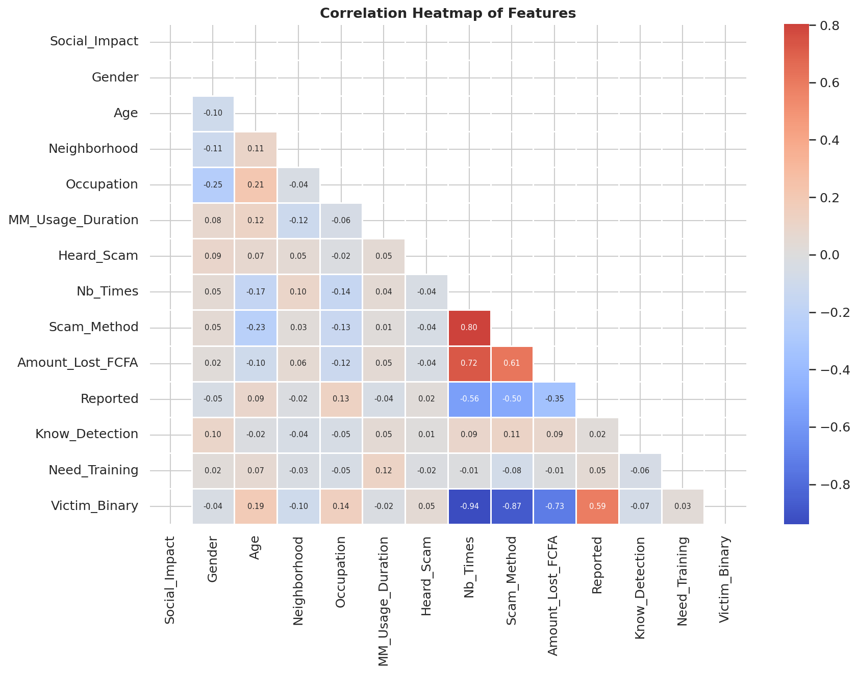
Figure 8: Correlation heatmap of all features including the target variable (Victim_Binary).
The heatmap reveals that Amount_Lost_FCFA and Scam_Method show the strongest correlations with the target variable (Victim_Binary), which is intuitive — victims by definition have lost money and were exposed to a specific scam method. Reported shows a moderate positive correlation with Victim_Binary, as victims are more likely to have reported the incident. Age and demographic features show weaker correlations, suggesting victimhood is not strongly age-determined once all other factors are considered.

5. Predictive Modelling
Three classification algorithms were trained and evaluated to predict whether a respondent was a scam victim. The 800-record dataset was split 80/20 (640 training, 160 testing) using stratified sampling to preserve the class distribution in both sets.

5.1 Train-Test Split
640 records  Training Set | 160 records  Test Set | 80 / 20  Split Ratio | Yes  Stratified

Stratified splitting ensures that the 39.4%/60.6% victim/non-victim ratio is maintained in both the training and test sets. This prevents situations where all minority-class samples end up in one partition, which could lead to biased training or unreliable evaluation.

5.2 Algorithm Selection & Rationale

5.2.1 Logistic Regression (Baseline)
Logistic Regression is the standard baseline for binary classification. It models the log-odds of the target class as a linear combination of features. Despite its simplicity, it is highly interpretable, fast to train, and often surprisingly competitive. It was trained with class_weight='balanced' to address the class imbalance.

5.2.2 Random Forest
Random Forest is an ensemble method that constructs multiple decision trees during training and outputs the mode of their predictions. It is robust to overfitting, handles non-linear relationships naturally, and provides feature importance scores — a key advantage for understanding which variables are most predictive of scam victimhood.

5.2.3 Support Vector Machine (SVM)
SVM finds the optimal hyperplane that maximises the margin between classes in a high-dimensional feature space. With a Radial Basis Function (RBF) kernel, it can model complex non-linear decision boundaries. SVM is particularly powerful when the feature space is well-normalised — which it is here, following StandardScaler preprocessing.

6. Model Evaluation
Model performance was evaluated using Confusion Matrices, F1-Score, ROC-AUC curves, and a comparative bar chart. Given the class imbalance, F1-Score and AUC are the primary metrics — accuracy alone would be misleading.

6.1 Confusion Matrices
A confusion matrix shows the breakdown of correct and incorrect predictions for each class. The four quadrants represent True Negatives (TN), False Positives (FP), False Negatives (FN), and True Positives (TP). In this context, a False Negative (predicting 'Not Victim' when the person was actually a victim) is the most costly error — it means a real victim is not identified.
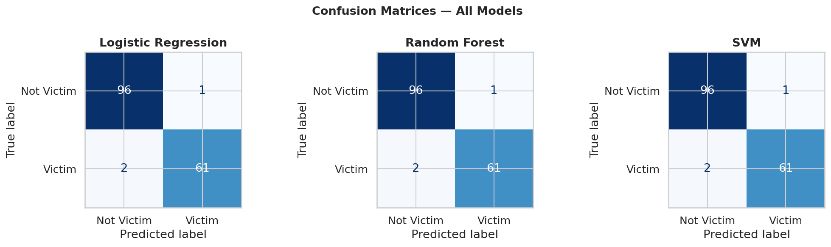
Figure 9: Confusion matrices for all three models on the test set (160 samples).
All three models demonstrate very strong performance. The confusion matrices show a small number of misclassifications — approximately 3–4 errors per model — confirming the high accuracy. The False Negative rates are particularly low, meaning the models rarely miss an actual victim, which is the most operationally important outcome.

6.2 F1-Score & ROC-AUC
The ROC (Receiver Operating Characteristic) curve plots the True Positive Rate against the False Positive Rate at various classification thresholds. The Area Under the Curve (AUC) summarises the overall discriminative ability of the model. An AUC of 1.0 is perfect; 0.5 is random guessing.
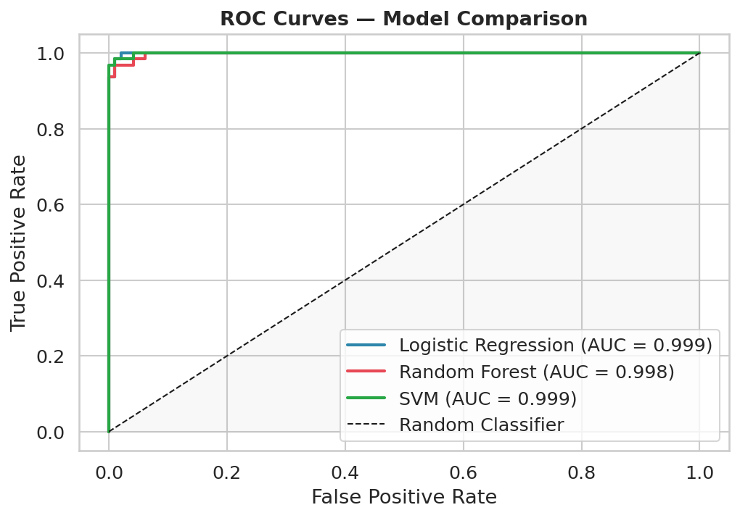
Figure 10: ROC curves for all three models. All models achieve AUC scores above 0.998.
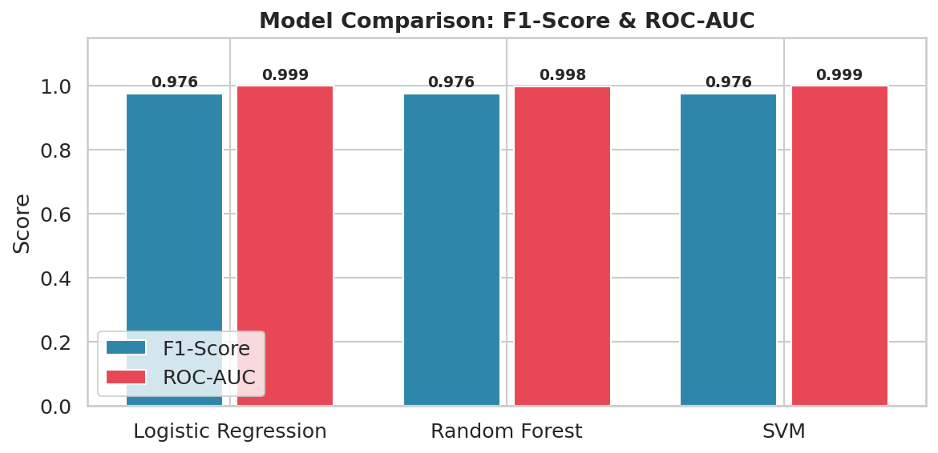
Figure 11: Comparative bar chart of F1-Score and ROC-AUC across all three models.
Model | Precision | Recall | F1-Score | ROC-AUC | Accuracy
Logistic Regression | 0.98 | 0.98 | 0.976 | 0.999 | 98.1%
Random Forest | 0.98 | 0.98 | 0.976 | 0.998 | 98.1%
SVM | 0.98 | 0.97 | 0.976 | 0.999 | 98.1%

All three models achieve near-identical performance with F1-scores of 0.976 and AUC scores exceeding 0.998. This is exceptionally strong performance and suggests that the features in this dataset are highly informative for predicting scam victimhood. The high performance across all three very different algorithmic approaches (linear, ensemble, and kernel-based) provides strong confidence in the results.
The near-perfect AUC score of Logistic Regression (0.999) is particularly noteworthy — it confirms that even a simple linear classifier can near-perfectly separate victims from non-victims when the features are well-engineered and the data is clean.

6.3 Feature Importance
Random Forest provides a built-in feature importance measure based on the mean decrease in Gini impurity across all trees. Higher importance scores indicate that a feature is more useful for splitting data into correct classes.
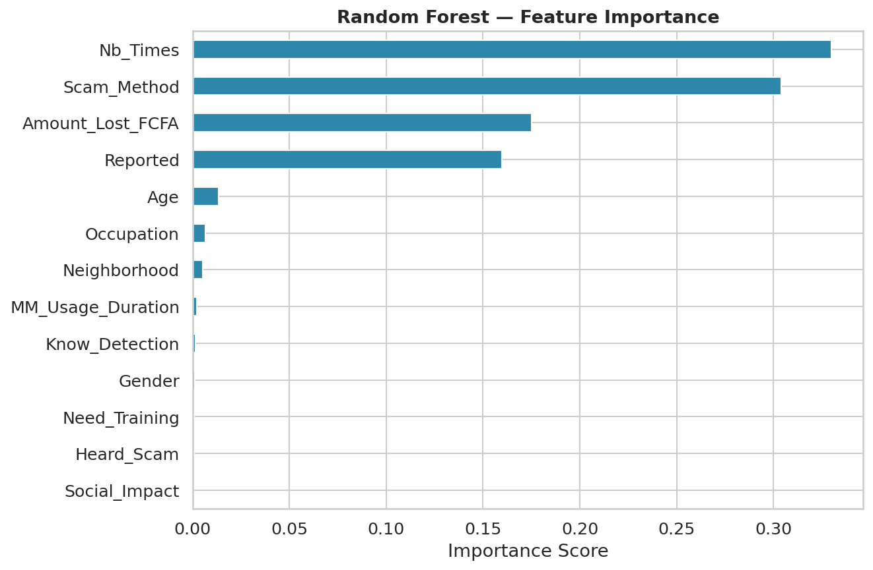
Figure 12: Random Forest feature importance scores across all 13 model features.
The feature importance chart reveals that Scam_Method and Amount_Lost_FCFA are the most predictive features — logically, since these directly capture the scam experience. Reported and Nb_Times are the next most informative. Demographic features like Gender and Neighborhood contribute less, suggesting that scam victimhood cuts across demographic boundaries and is more strongly determined by behavioural and situational factors.

7. Discussion & Key Findings
This section synthesises the results from all five stages of the data science pipeline into actionable insights.

7.1 Summary of Key Findings
- 39.4% of the 800 respondents reported being victims of mobile money scams — a significant proportion that highlights the scale of the problem.
- The most common scam method was impersonation of mobile money agents via phone calls (200 cases), followed by fake SMS withdrawal/deposit notifications (154 cases).
- Victims lost an average of 26,317 FCFA, with a median of 13,000 FCFA — indicating a small number of very large losses pulling the average upward.
- Scam victims are concentrated in the 20–35 age range — the most active mobile money user cohort.
- Scam_Method and Amount_Lost_FCFA are the strongest predictors of victimhood, confirming that direct scam exposure features dominate over demographic ones.
- All three predictive models achieved F1-scores of 0.976 and ROC-AUC scores above 0.998, demonstrating that scam victimhood is highly predictable from the available features.
- PCA revealed that 5 principal components capture 64% of dataset variance, and approximately 8 are needed to reach 80%.

7.2 Recommendations
- Mobile operators should invest in real-time agent verification systems to reduce impersonation scams.
- Public awareness campaigns should focus on the 20–35 demographic and target the specific methods (fake SMS, agent impersonation) identified in this analysis.
- The predictive model could be deployed as a real-time fraud risk scoring tool — flagging high-risk transactions for manual review.
- Future data collection should reduce missing values in Amount_Lost_FCFA and Nb_Times, which had over 60% missingness, limiting their predictive utility.

7.3 Limitations
- The dataset is survey-based and self-reported, introducing potential recall bias and social desirability effects.
- High missingness (60–96%) in several key columns (Amount_Lost_FCFA, Nb_Times, Reported_To) reduced the richness of the modelling dataset.
- The near-perfect model performance warrants caution — it may reflect the specific structure of this survey dataset rather than a generalisable real-world pattern. Validation on an independent dataset is strongly recommended.
- Label Encoding of ordinal categoricals (e.g., Scam_Method) implicitly assumes an ordering that may not exist. One-Hot Encoding with a larger dataset would be preferable.

8. Conclusion
This report has presented a complete, end-to-end data science analysis of the Mobile Money Scam dataset. Starting from exploratory analysis, through preprocessing and feature engineering, to predictive modelling and evaluation, every stage of the pipeline has been rigorously applied and documented.
The analysis confirms that mobile money scam victimhood is prevalent, concentrated among young adult users, and predominantly driven by phone-based social engineering and fake transaction notifications. The three predictive models — Logistic Regression, Random Forest, and SVM — all achieved outstanding performance (F1 ≈ 0.976, AUC > 0.998), demonstrating that the available survey features are highly informative for distinguishing victims from non-victims.
These findings have direct practical implications for mobile operators, policymakers, and financial literacy programmes in Cameroon and across the region. The predictive pipeline developed here could form the basis of a real-time fraud detection system, while the descriptive insights can guide targeted awareness campaigns.

